SUKKUR IBA UNIVERSITY
MERIT – QUALITY – EXCELLENCE

Department of Electrical Engineering

Guidelines for making
FYP videos

Final Year Project Committee:
Engr. Dr. Muhammad Waqas Soomro (Head)
Engr. Ghulam Akbar, Engr. Aizaz Ali, Engr. Qasir Ali (Members)
Marketing & Outreach Team:
Engr. Dr. Abdul Aziz Memon, Engr. Dr. Ahmed Ali Shah
Engr. Dr. Nabeel Ahmed, Engr. Mohammad Fawad, Engr. Mahnoor Mughal

Dear students,
Your FYP video will be made available to the whole world through departmental YouTube channel, so make amazing and exciting videos with useful content.
Channel name: Electrical Engineering Sukkur IBA University:
https://www.youtube.com/channel/UC_wia8rRfRyrbqnFRvpc9Ew/videos

You have to submit two videos.

Short video: (2~4 minutes maximum): Animation style with background music
First slide (07 sec) https://www.dropbox.com/s/o4yj82tv6ni8pj6/Slide%20First-Thumbnail.pptx?dl=0
Inside content (2~3 minutes): Journey of FYP from scratch to end with short videos + pics + your voice/text labels (Working on hardware, software, achieving final product, results, simulations etc.)
Note: keep taking pictures and making short videos
FYP poster (10 to 15 seconds: Full poster then zoom-in individual portions and then zoom-out)
Last slide (07 sec) https://www.dropbox.com/s/udtorhphwlpltnj/Slide%20Last.jpg?dl=0

Long video: Duration of video should be less than 30 minutes.
Example videos can be seen on EE SIBAU channel
Add background music if you want to (Voice should be clear and louder than background music)

Video sections for long video:
First slide https://www.dropbox.com/s/o4yj82tv6ni8pj6/Slide%20First-Thumbnail.pptx?dl=0
Introduction to team members inside ppt in background + face to face on same time.
Project title, Introduction to Supervisor, co-supervisor
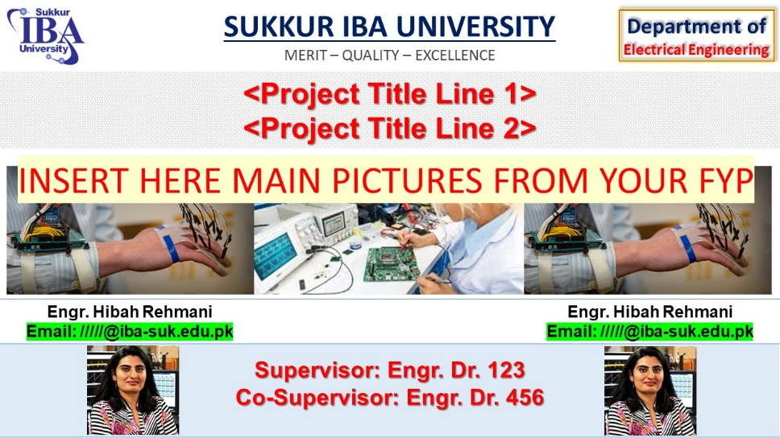

FYP Presentation (Same or better version of FYP PPT that you have prepared with the instructions provided by Dr. M. Waqas Soomro for final presentation)
FYP demonstration (Hardware, software or both (whichever methodology is adopted and implemented))
FYP poster (show actual poster and just tell that you have summarized your work into poster (don’t explain again))
Last slide (07 seconds) https://www.dropbox.com/s/udtorhphwlpltnj/Slide%20Last.jpg?dl=0
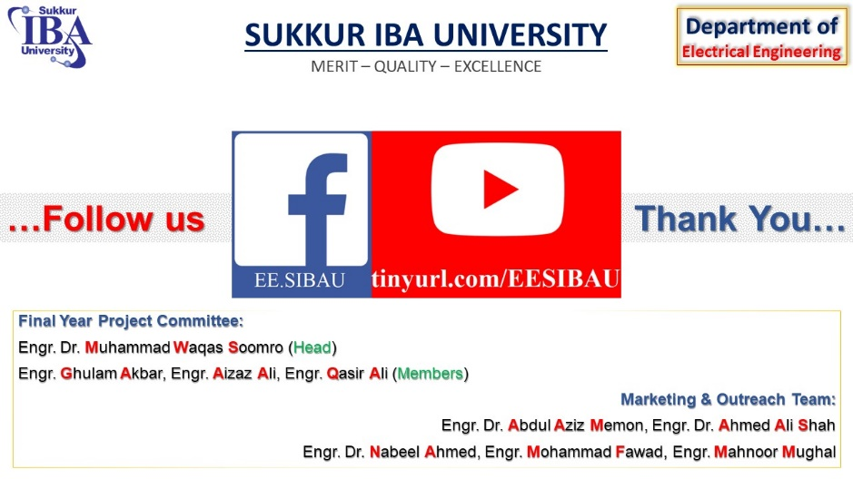
Provide following to Dr. Abdul Aziz through USB:
- Thesis file (word or editable format)
- FYP PPT file
- FYP Poster in soft form (Editable format)
- Provide first slide in PPT format
https://www.dropbox.com/s/o4yj82tv6ni8pj6/FYP%20video%20thumbnail.pptx?dl=0
- Provide first slide in image format as well
- Short video presentation with:
- Long video presentation with:
  - Use English language.
  - High quality video with same dimensions/style as YouTube videos (not as TickTock style)
  - No water marks of any video recording application.
  - Clear voice, no noise, same level of voice in whole presentation
  - No shaky video (Camera should be fixed and move slowly if required)
  - Proper lighting in surroundings with visible PPT text, no shadows, or extra light reflections/shadows.
  - Background music lower than voice
  - You can use slide/image/video transitions and in-slide animations are very much encouraged.
  - Do not stand in front of projected ppt (use LASER pointer).
  - If you cannot explain something well, skip it from video or explain briefly with confidence to avoid bad impression worldwide.
Submit to and get your videos checked by Dr. Abdul Aziz Memon

Recommended style for video:
- Small face video + slide + (must use cursor/pointer to point out that particular text/image)
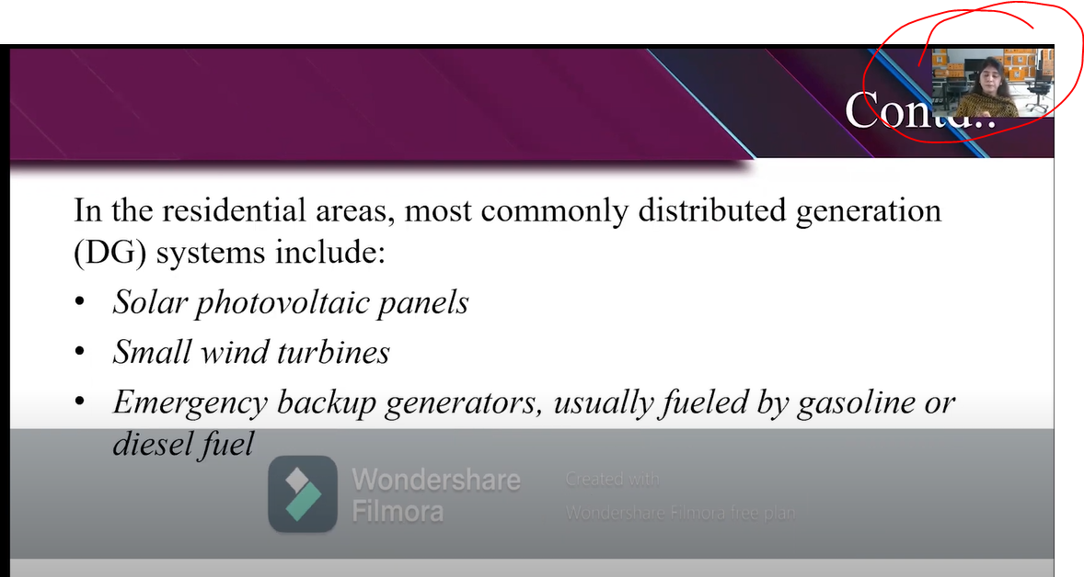
- Stand on right/left side of video presentation and explain + LASER pointer.
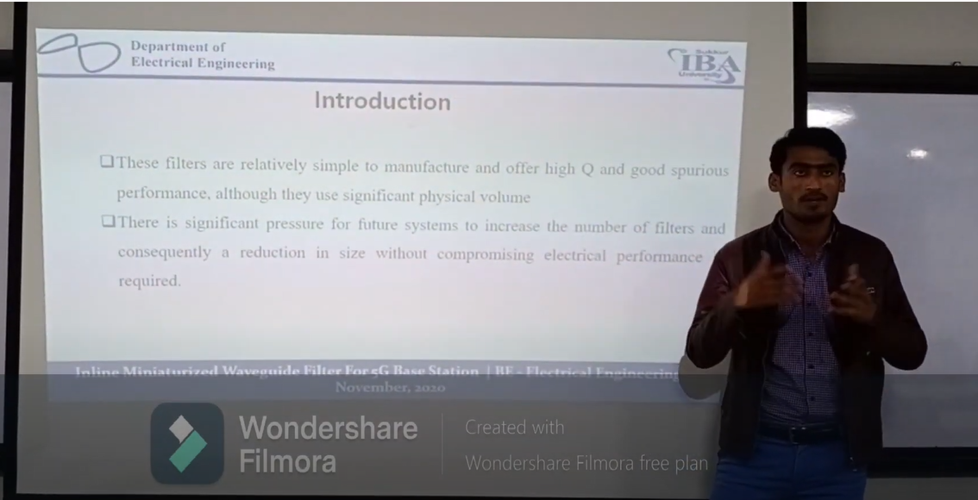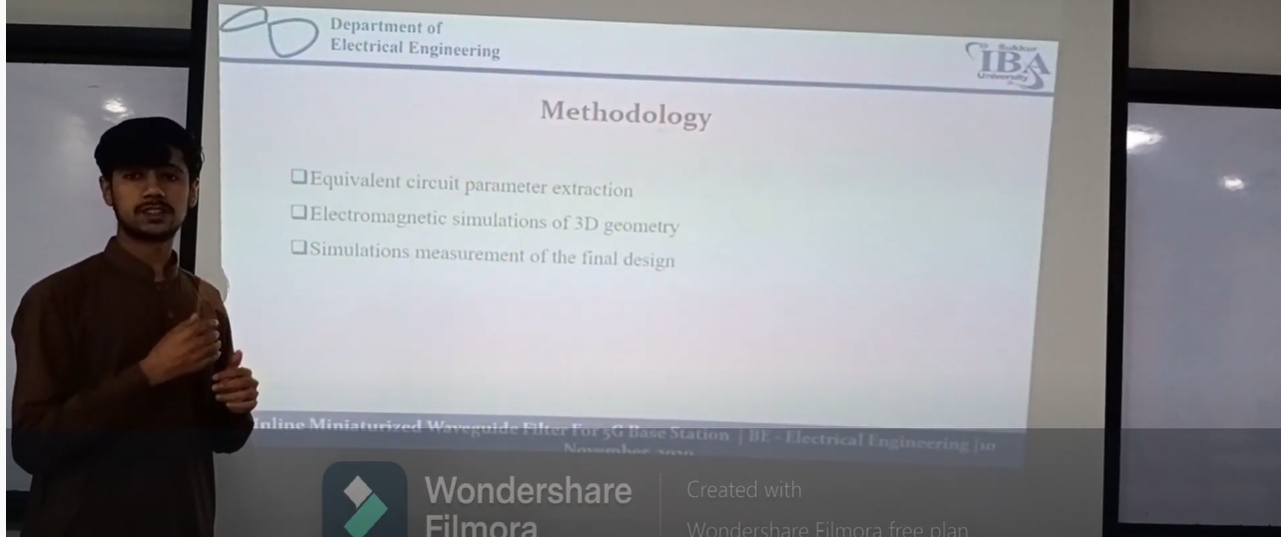
- Demostration must be included after presentation.
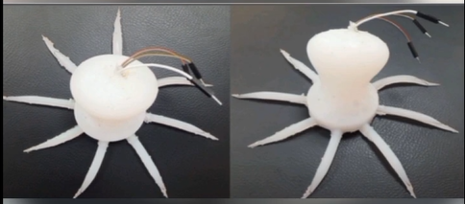
Not recommended:
Do not read like this. Use LASER pointer.
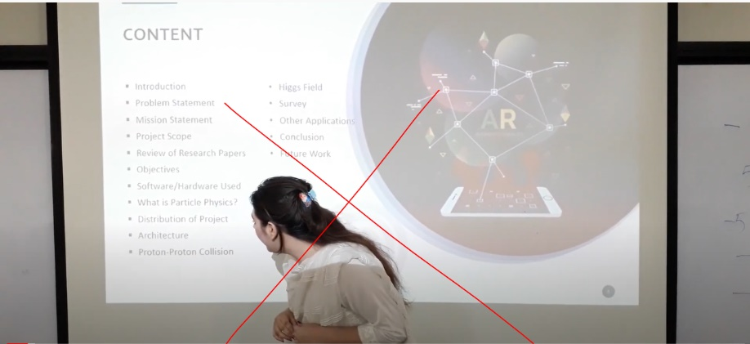
Do not stand in front of projected ppt.
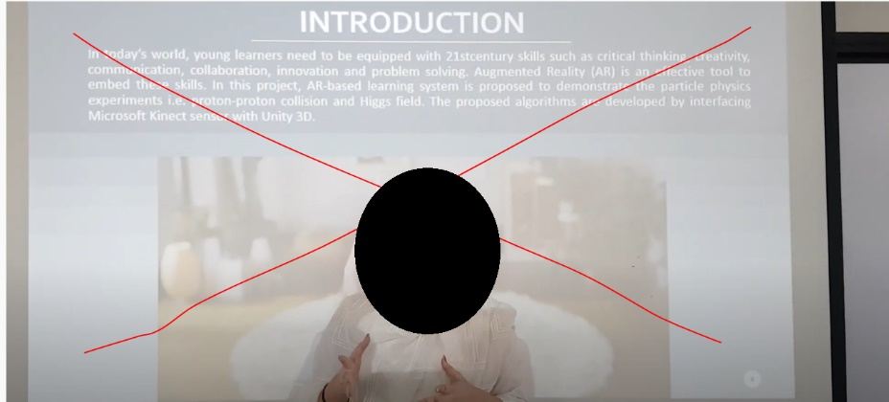

Tick tock style or video that does not cover full screen in YouTube style is not recommended.
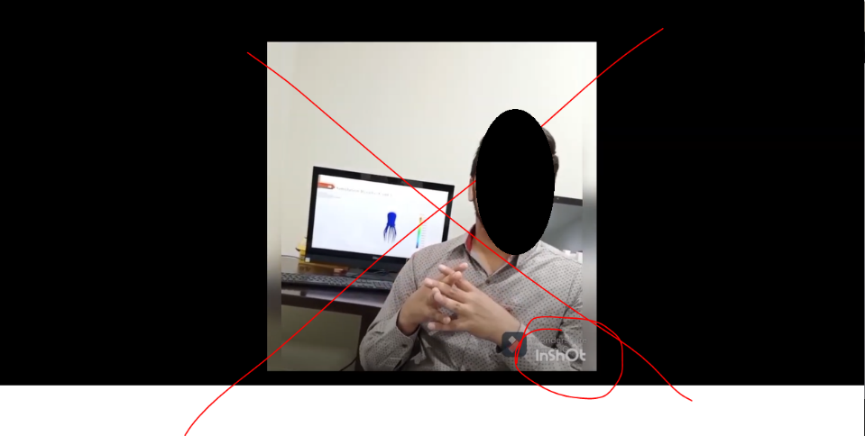
Watermarks are not recommended.
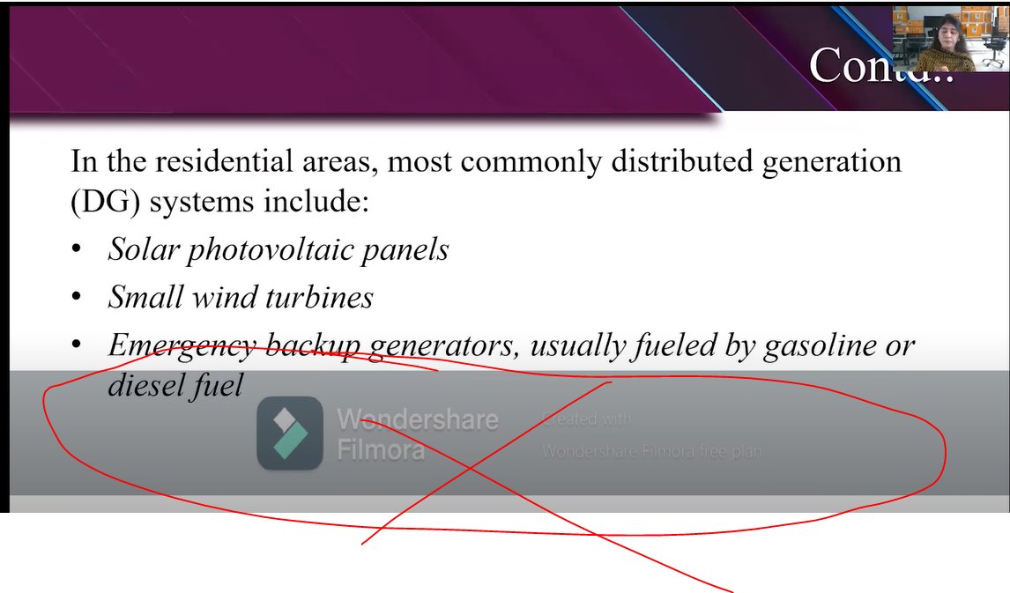
Bad alignment is not recommended.
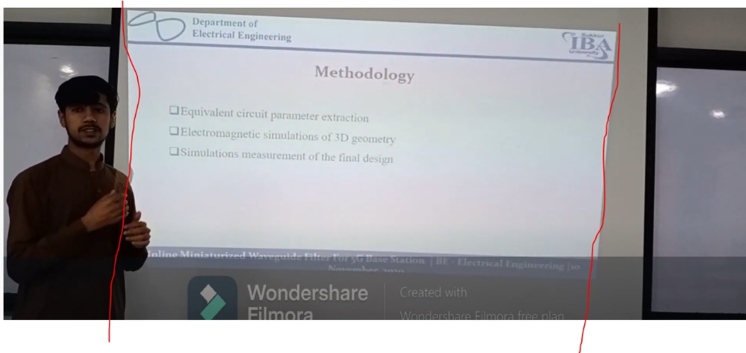

Just voice over, not recommended.
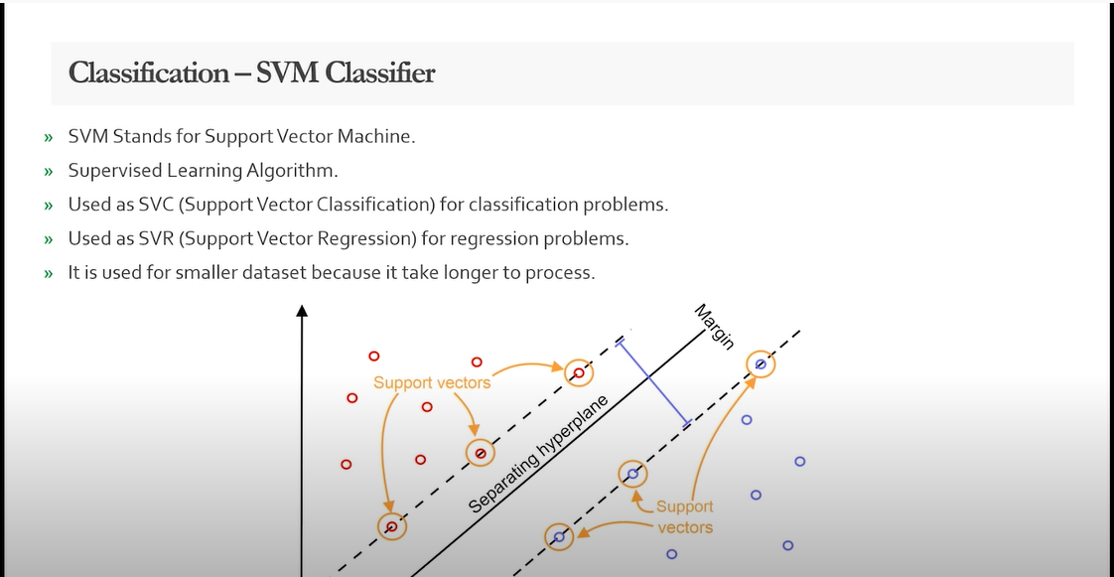

Video making tools: Filmora, Camtasia, Adobe Premiere
PS.
MUST SUBSCRIBE YouTube Channel
Any positive suggestion/recommendation to improve video contents by any student or faculty member is always welcomed.

